**Exercise 3: Assertions in JUnit**

**Scenario:**

You need to use different assertions in JUnit to validate your test results.

Steps:

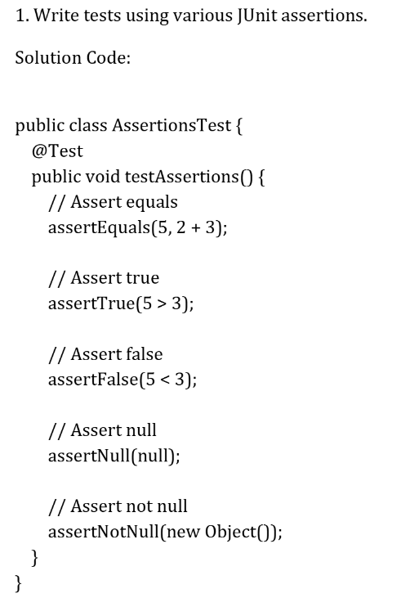

**SOLUTION:**

**package** hands_on;

**import** org.junit.Test;

**import** **static** org.junit.Assert.*;

**public** **class** AssertionsTest {

@Test

**public** **void** testAssertions() {

// Assert equals

*assertEquals*(5, 2 + 3);

// Assert true

*assertTrue*(5 > 3);

// Assert false

*assertFalse*(5 < 3);

// Assert null

*assertNull*(**null**);

// Assert not null

*assertNotNull*(**new** Object());

}

}

